1. What communities are in Mastodon

There are four communities in Mastodon.

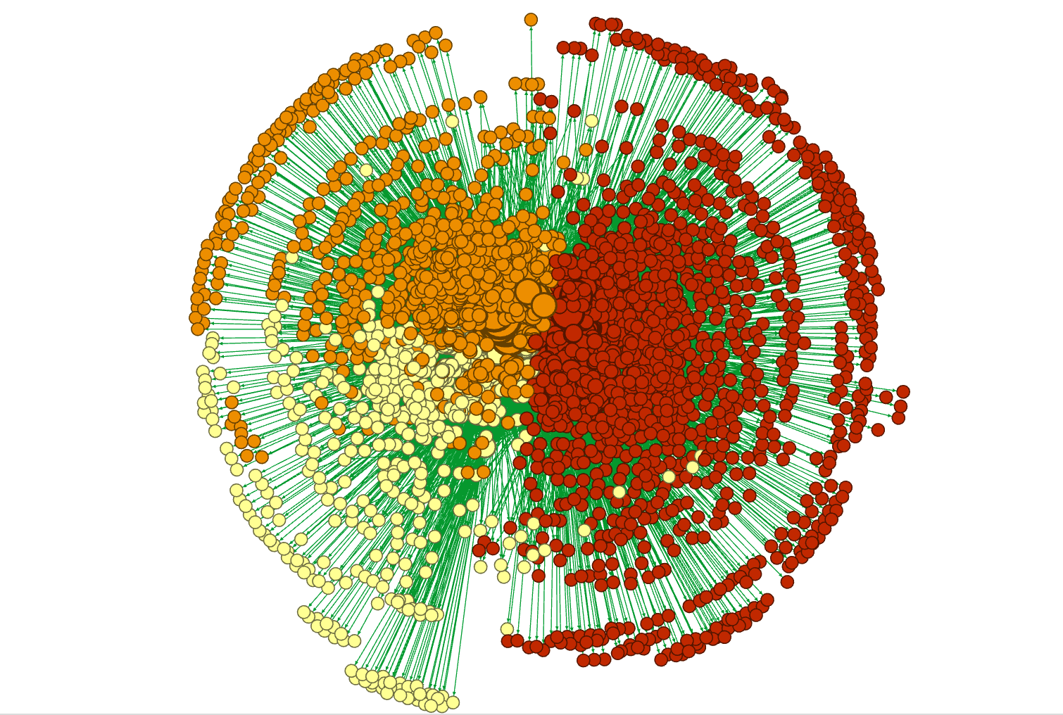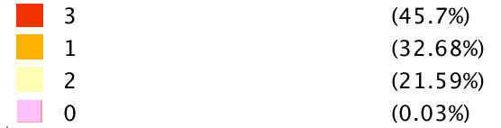

If we zoom in, we can see that the majority group are most originated from Japan. The second large community is mostly about casual events( cafe, cat or travel), while the third largest component is about technology, club and social.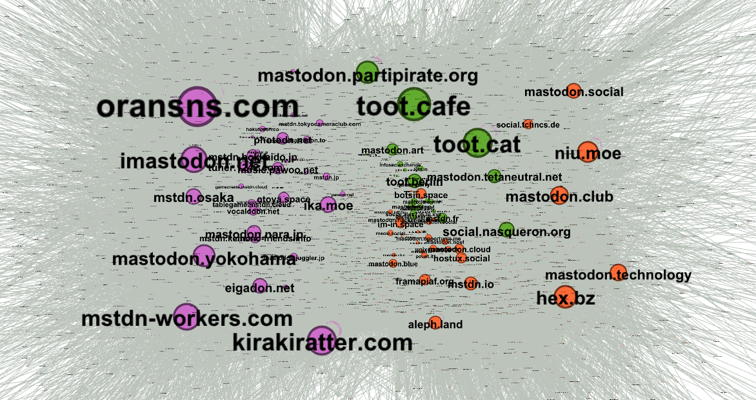

2) Popular instance don’t necessarily connect with more other instances

Nodes present here are popular nodes with high in-degree, which means they are popular among instances. However their out-degree are all very small(scale of the node means their out-degree rank). Especially those nodes market with red spot, they have 0 out-degree but plenty in-degree.

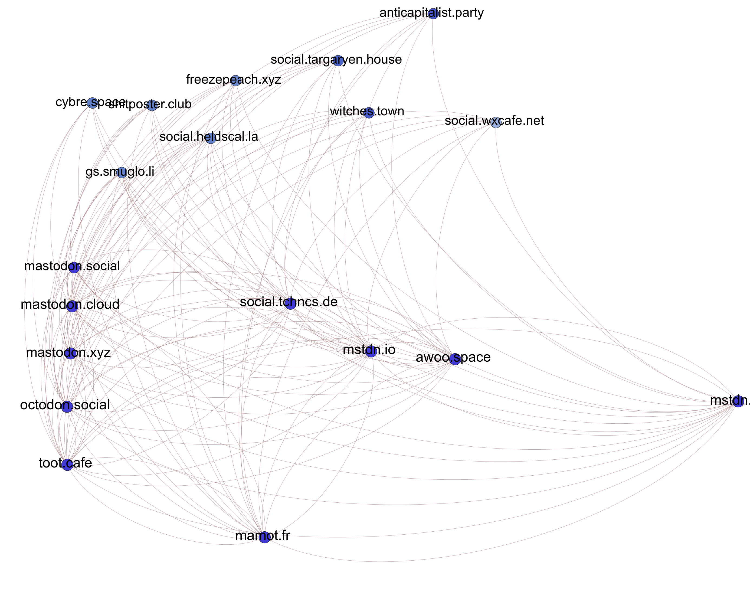

3) Nodes with high betweenness and Authority score

The color of the nodes means their community class. This group has been filtered with high authority. The scale of the nodes means their betweenness rank. As we can see, nodes with highest betweenness and authority is toot.cafe, [kikarkiratter.com](http://kikarkiratter.com) and mastodon.social.

